Power Up Procedure

- Ensure the Avid HD I/O (32X32) interfaces are powered on

- Ensure the speakers are powered on
-2x ATC SCM12 PRO Monitor speakers. (These monitors are passive and require power using the Yamaha PX3 power amp, which should already be active when entering the studio.)
-2x Genelec 8030c active studio monitors

- Ensure the Mac Pro and displays are powered on
-Locate the Sonnet rack to power on the Mac Pro (labelled, Mac Power Switch)
-The Apple Cinema Displays will auto power on

Power Down Procedure

- Ensure your work is stored to either Data drive and back this up to external media
Any work stored in alternate locations will be automatically deleted upon system restart

- Restart the Mac Pro (Apple Logo > Restart) to remove user settings

Patching

- Microphones are patched into the Control Room via the Wall Patch Panel in the Live Room.
Please ensure you are patching into the correct Control Room (‘Audient’, as opposed to C24)

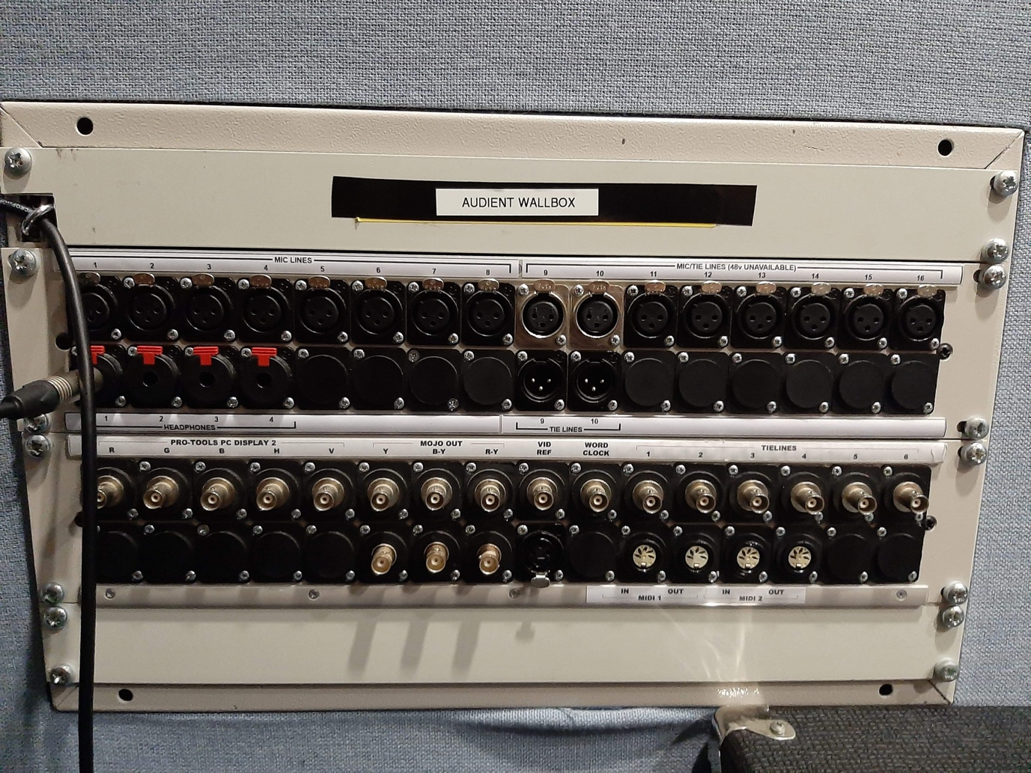

- 10x Microphone stands and multiple XLR cables are to remain in the Live Room
All microphones and further stands and cables should be borrowed from the Resource Centre located in the Hugh Aston building

- Microphones & DI Boxes are available in the wooden microphone cupboard
Do not remove these microphones from the live room and report any issues immediately

Connect performer’s headphones to the ¼” headphone outputs via the Wall Patch Panel in the Live Room, starting with output 1

Pro Tools Ultimate 2019- Session Setup

- Launch Pro Tools Ultimate 2019 from the Mac OSX Dock
If you have issues launching any DAW software, please restart the Mac

- At the on-screen dialogue, select a new session or load a previous session

- If launching a new session ensure the following parameters are chosen:
-44.1KHz Sample Rate (Higher if desired)
-16 Bit Depth (Higher if desired)
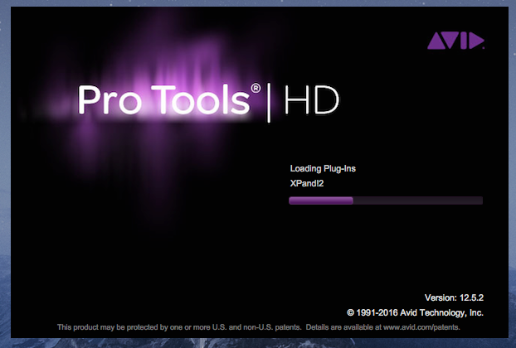

- Click OK to proceed and save your session. Save to the Data or Data2 only
Saving to a different location will result in your work being automatically deleted upon system restart

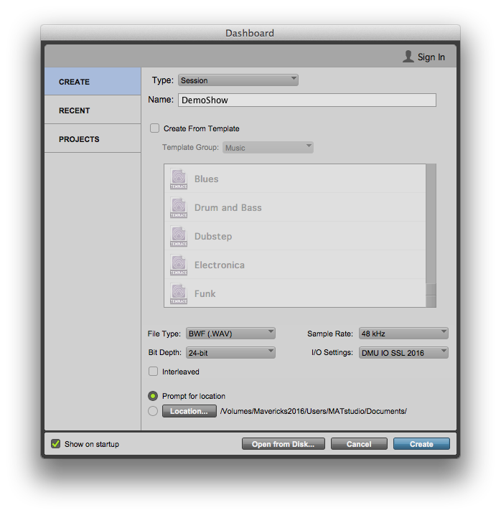

- Save your session with an appropriate name
Use your P Number and work/song title to easily locate your saved recording
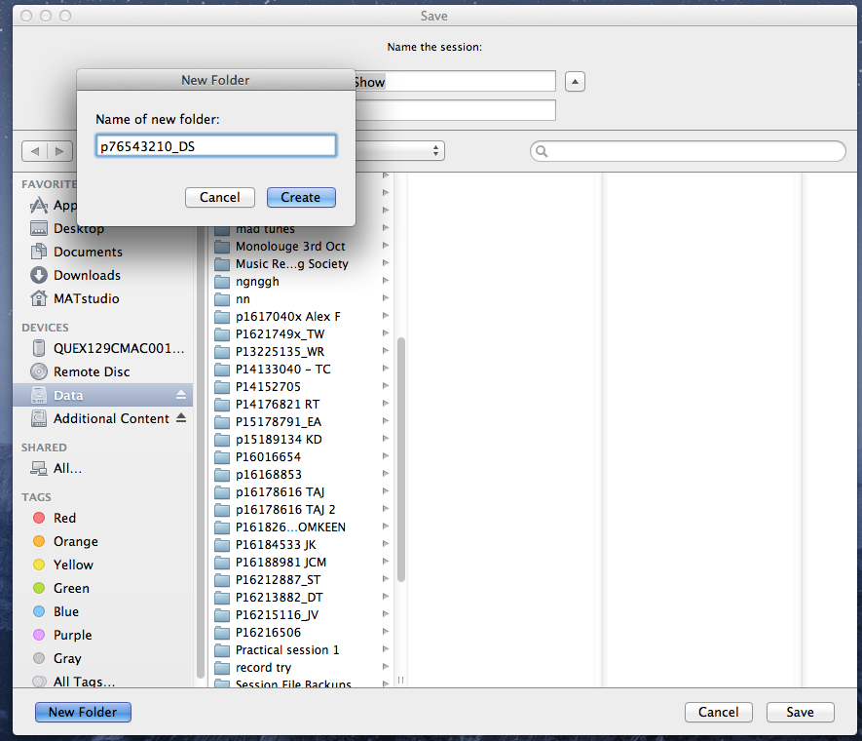

- Click Track > New > … Create to add new tracks
Select the number of tracks you wish to add
Select between mono/stereo
Select the type of track (Audio/MIDI/Instrument/VCA/Master)
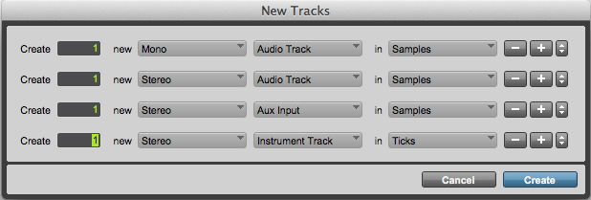

- Ensure your track routing is correct (Input and output routing)
Ensure input 1 is selected if your microphone is patched into wall input 1
Ensure Speakers. Stereo is selected if working in Stereo
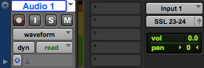

- Change the input/output routing if using alternate inputs or working in surround. (To monitor the DAW signal path only, select ‘Tape 1’ on the monitoring section within the Audient console).
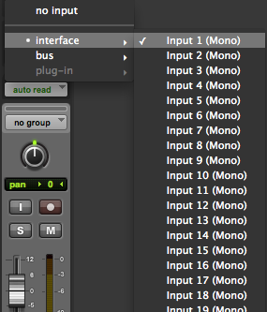

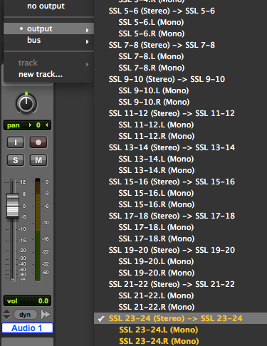

Mic Pre-Control
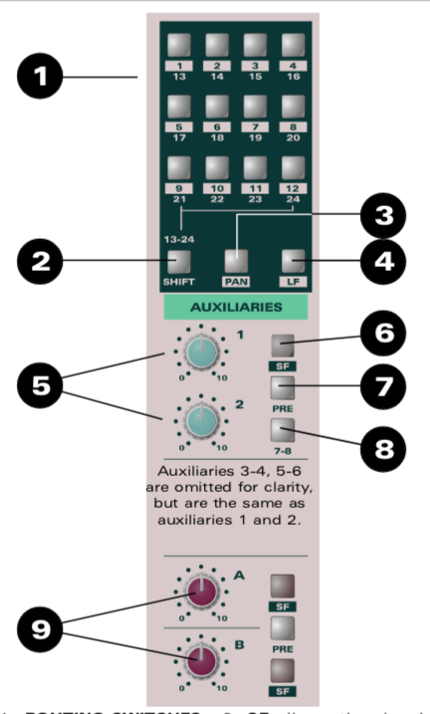
- Channel Input Selection- (Input’s plugged into from the live room will need to be and applied in each channel strip)
- Shift- (Allows the user to utilize channel mapping outputs from 13 to 24.)
- Pan- (Allows the user to pan an audio signal to odd and even groups)
- LF- (This function allows the user to replace the SF signal that is being sent to the routing with the LF signal path, useful for track bouncing. Auxiliaries can also be switched to the SF path.)
- Level- (This function allows the user to adjust the volume level sent to an auxiliary path.)
- SF- (Signal path option used to allow the auxiliary to be taken from the SF path.)
- Pre- (This allows the user to take the auxiliary signal pre fader (before) as opposed to post fader (after).)
- 7-8- (Gives the option of routing the audio signal’s to channels 7-8 instead of channels 1-2.)
- A/B- (The auxiliary paths are identical however this option allows the user to separate the two signal flows into the SF path.)

Input Strip Operation.
EQ
- HF/LF- High Pass Filter 10kHz-18kHz, Low Pass Filter 50Hz-100Hz
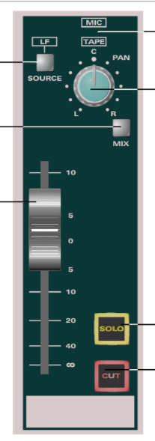
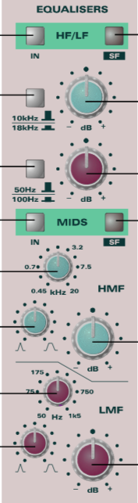
- Mids- HMF (High Mid Filter) 450Hz- 20Khz- LMF- (Low Mid Filter)- 50Hz- 1Khz

Logic Pro X- Session Setup

- Launch Logic Pro X from the Mac OSX Dock
(If you have issues launching any DAW software, please restart the Mac)
After this, choose a project type for example ‘Empty Project’
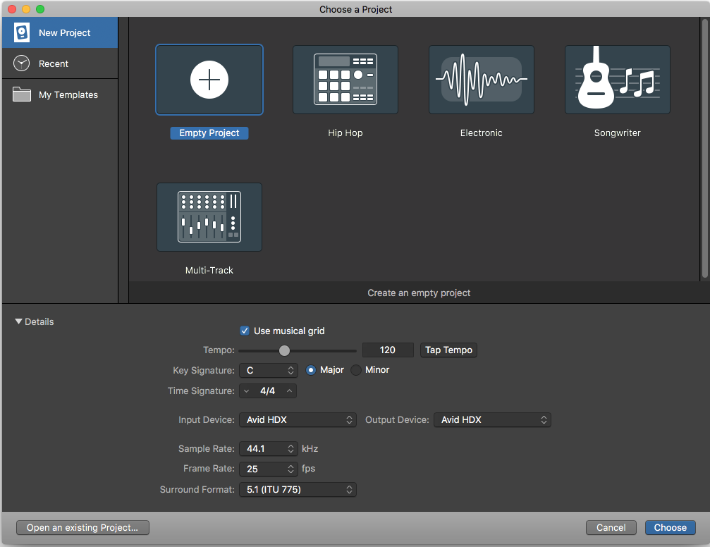

Ensure the desired sample rate of the session is running at 44.1kHz or higher, and that the input device and output device is set to ‘Avid HDX’.

- Once the project type has been chosen, choose a desired type of audio track e.g. audio, software instrument, midi etc.

- Next ensure the input is correctly stated and the output is selected as 1 and 2 for the monitoring… (for example input 1 from the Audient wall box within the live room…)
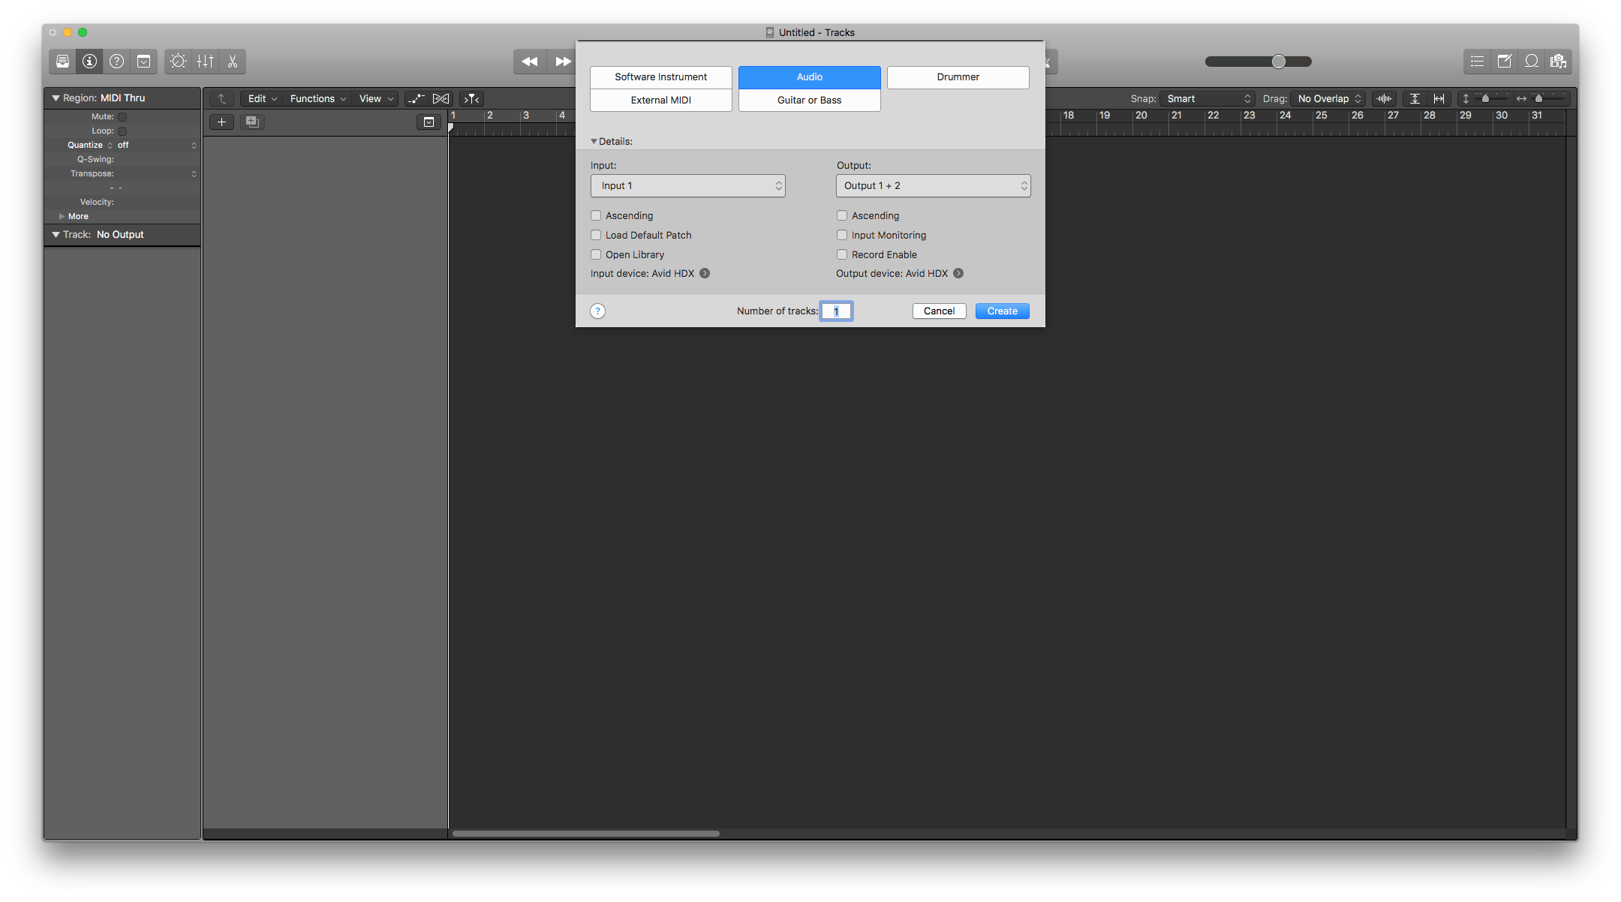

- Ensure using the mix view, that the channel is correctly sourced as ‘Mic’ if recording using ‘Mic Lines’ or ‘Line’ if using ‘Tielines’ via the wall box. Inputs and outputs can also be seen and altered using the mix view.

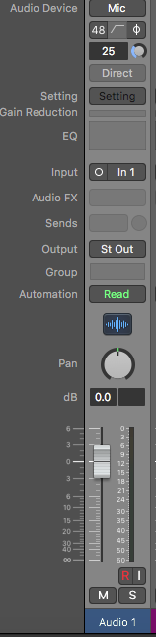

Basic Tracking Setup

- Launch Logic Pro X

- Create new track (choose audio, midi or software instrument for the desired source)

- Ensure the channel’s input and output routing is correct (output select Avid HDX)

- Set Console Output fader to unity

- For headphone monitoring ensure FB/A is active on the monitor section of the console, And the Behringer headphone amp in the rack is powered on (adjust level sends using the trims on the desired channels)

- Record Arm the channel selecting ‘R’

- Use input monitoring ‘I’ if desired to hear the monitoring signal from Logic Pro X

- Commence recording using the arrange bar section within Logic Pro X selecting the record arm button

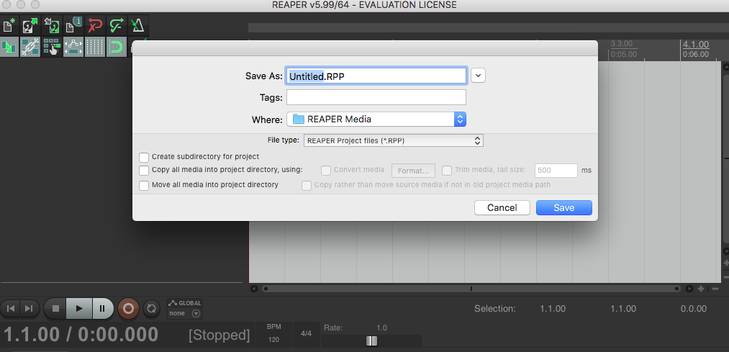
Reaper—Session Setup

- Launch Reaper from the Mac OSX dock.
If you have issues launching any DAW software, please restart the Mac.

- Select ‘File’ and open either a ‘New Project’ File, ‘Recent’ file or use the ‘Open File’ parameter to browse and open specific files.
- Name your session appropriately

- For mapping a input and output device, Choose the following parameters via (Reaper/Preferences/Audio/Device:
- Sample Rate: 48kHz (higher if desired).
- Bit rate: 24 bit (higher if desired).

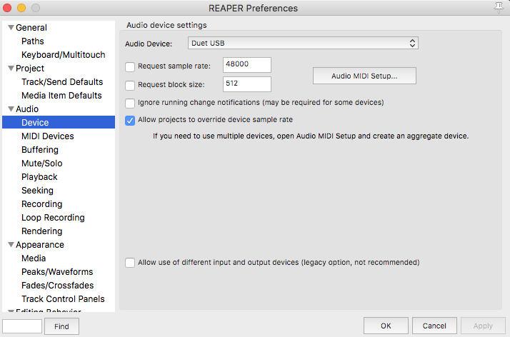

- Click OK to save the session INSIDE A FOLDER carrying
YOUR P-NUMBER onto one of the DATA DRIVES ONLY!
Saving to a different location will result in your work being
automatically and irrevocably deleted upon system restart.

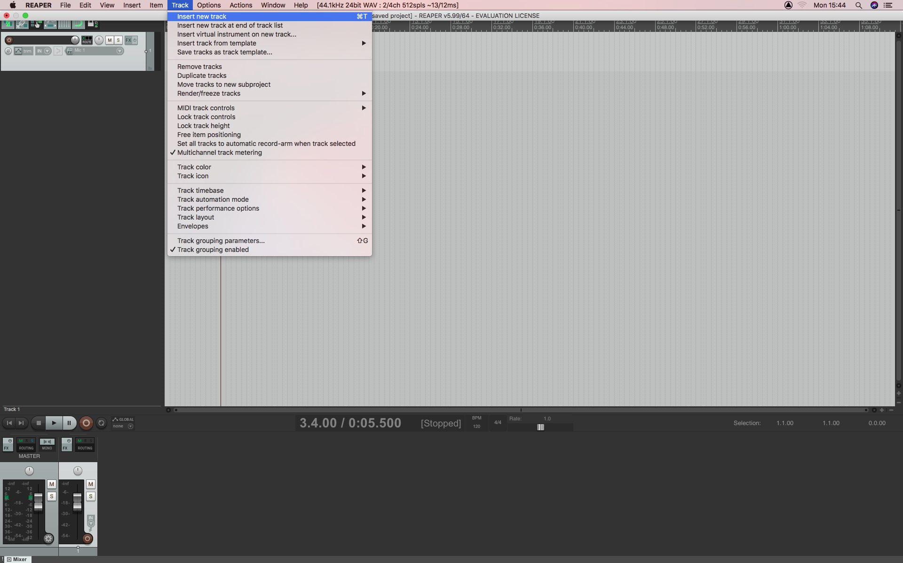
- To insert a new track select the following parameters: (Track, Insert New Track)
- Ensure the inputs and outputs are correctly mapped selecting the ‘Routing’ tab on the inserted audio channel, this can be found using the ‘Routing Matrix’ also which can be accessed via ‘View’ tab and selecting ‘Routing Matrix’ .
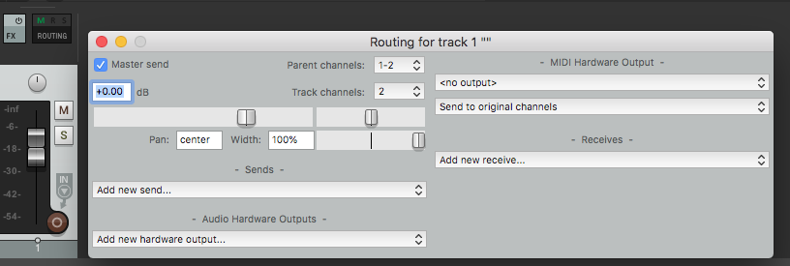
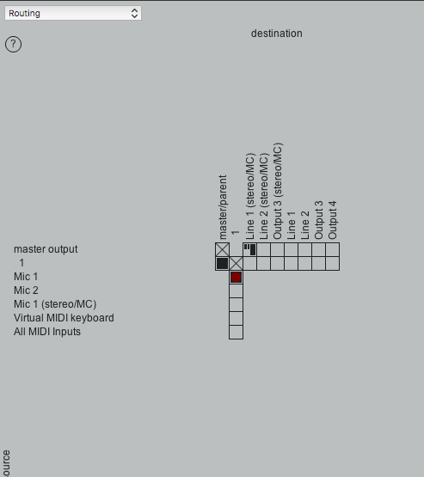
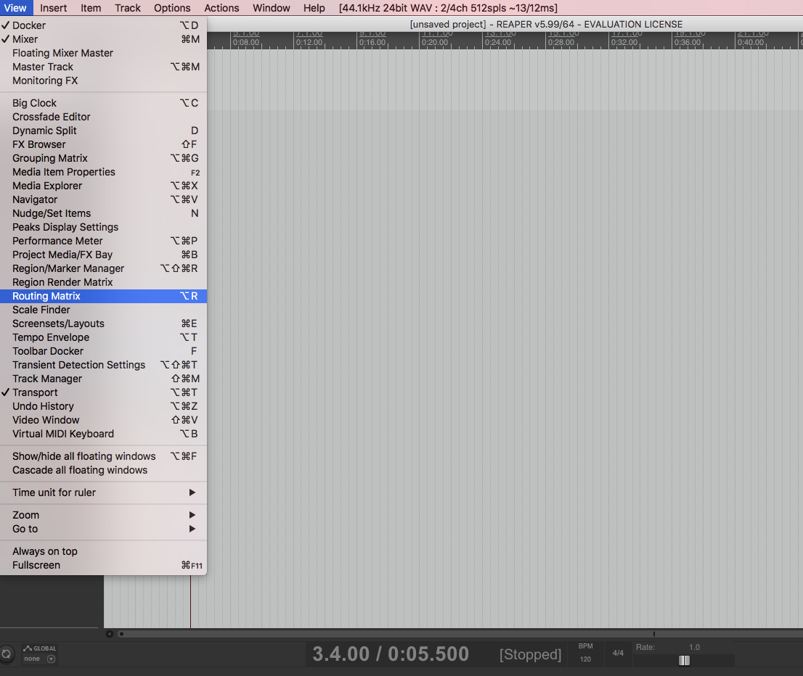
To commence recording, ensure the ‘Record Arm’ button is selected on the audio channel strip

