Sound Booths
Booth-1

User Guide

Please find general studio support guides in the ‘Help Me’ folder on the Mac desktop.

Sound Booths
Protocol

Save your work to the Data drives only
- Do not save work to the desktop or the system drives. It will be deleted upon restart.
- Please ensure you always back up your work to external media in case of data loss.

Food & drink is not permitted
- Please use the common areas for consuming refreshments.

Please report any studio faults in the sound booths immediately
- Consult this document or the PDF Studio Guide found on the desktop to ensure the suspected fault is not user error.
- Locate one of the technicians @ Q1.38 during office hours or email audiotech@dmu.ac.uk or use the fault form @ www.mti.dmu.ac.uk/must/tech/fault.php.

Leave the sound booths as you would expect to find it
- Please endure the control room and live rooms are left in a tidy manner.
- All items should be returned to their respective stores, microphone stands folded back and cable rolled up appropriately.

Reset the computer
- Please restart the computer after finishing so the next user has a fresh working environment.

Failure to comply with these rules will result in the termination of your studio access.

Sound Booths
Overview

Power Up Procedure 4
Power Down/Restart Procedure 5
Basic Tracking Setup 6
Pro Tools Session Setup 7
Logic X 10
Reaper 12
AVID Transport Controls 14
External Macbook/Laptop Setup 15
Moving Pro Tools 11 Projects 16

Power Up Procedure
The booth studios should be powered up automatically due to the set time schedule for automatic restart. In the event of failure to do so, please take the power up procedure step by step below…

- Ensure the Focusrite Scarlett 18i20 is powered on.
- Ensure the speakers are powered on.
- 2x Adam A5X speakers; flip the switch at the power plug.
- Ensure the Mac Pro and displays are powered on.
- Power switch on the front left of the silver Mac Pro.
- The monitors have their own power supply; make sure they are switched on at the power plug.

Power Down/Restart Procedure

- In general, it is not necessary to shut down.
- All Mac Pros are on a schedule and will boot, respectively shut down, automatically.
- Please make sure you have saved your work and closed the programs.
- Ensure your work is stored to either Data drive as well as backed up to external media.
- Any work stored in alternate locations will be automatically deleted upon system restart!
- Restart the Mac Pro (Apple Logo > Restart) to remove user settings in case the computer shows strange behaviour or does not work as expected.
- The computer will automatically log on, using the studio user profile (‘Soundbooth-1’)

Basic Tracking Setup

- Gain staging is achieved with the Focusrite Scarlett 18i20.
- Ensure the Monitors are switched on.
- Ensure input source is set to the correct source (front or rear or mic line).
- Engage phantom power where applicable.
- Do not turn phantom power on until the microphone is connected!
- Ensure the Volume knob on the Focusrite Scarlett 18i20 is set appropriately.
- Record-arm your audio tracks in Pro Tools to commence tracking
- Rotate the channel input gain knob until achieving a healthy signal
(circa -18dBFS on the input meters).
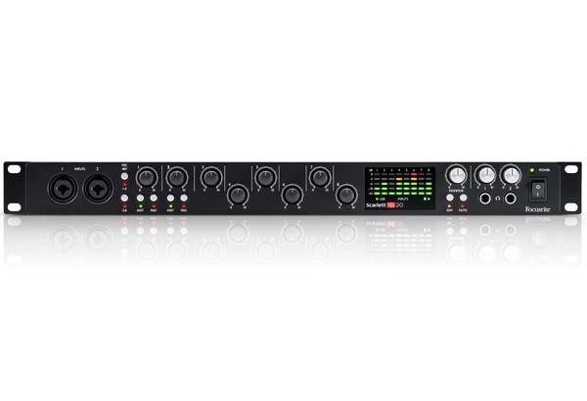
Headphone Volume trims/inputs

Input Level Meter (dB)
Pad (-10dB)
Instrument Level (Line)
XLR Input (Mic Level)
Phantom Power Activation (+48v
Phantom Power input selection- 1-4, 5-8
Gain Trim
Monitor Level
Mute
DIM (temporary monitor reduction)
Power On/Off

Pro Tools 2019 Session Setup

- Ensure ‘Core Audio Manager’ is not running and therefore allowed to start up before/together with the DAW.
- Launch Pro Tools from the Mac OSX Dock.
- If you have issues launching any DAW software, please restart the Mac.
- At the on-screen dialogue, select a new session or load a previous session.
- If launching a new session ensure the following parameters are chosen:
- Stereo Mix (to ensure the I/O routing is correct).
- 44.1KHz Sample Rate (or higher if desired).
- 16 Bit Depth (or higher if desired).
- Click OK to proceed and save your session with an appropriate name.
Save to the Data or Data2 only!
- Saving to a different location will result in your work being automatically deleted upon system restart.
- If not already existing, create your own folder on the chosen drive using your p-number and name.
- All subsequent projects can be saved inside there with a corresponding title.
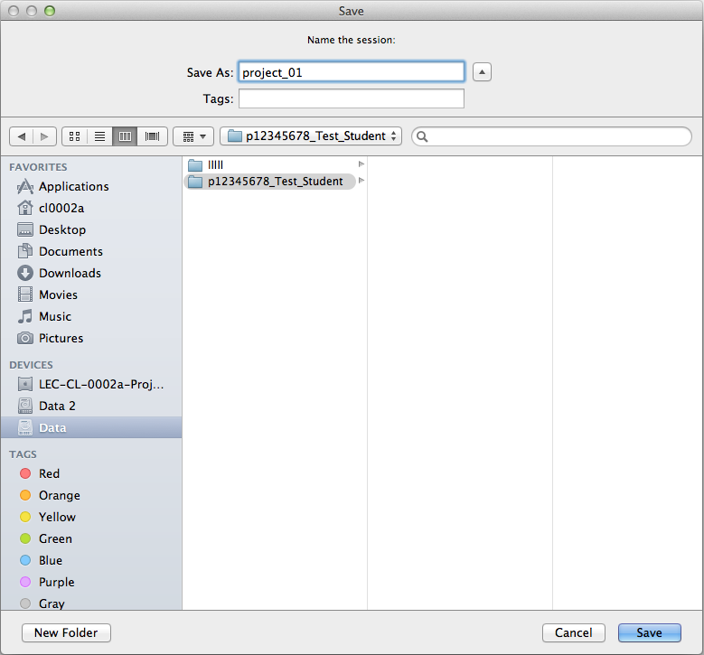

- Tracks
  - Click Track > New > … Create to add new tracks.
- Select the number of tracks you wish to add.
- Choose between mono/stereo.
- Select the type of track (Audio/MIDI/Instrument/VCA/Master).
- It is possible to create different kinds of tracks at the same time using the plus (+) sign on the right.
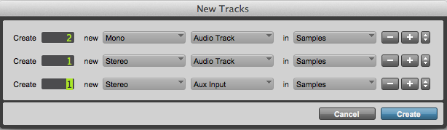
  - Click File > Import > Audio… to import files.
- Select the files you wish to add.
- Choose to ‘Convert’ or ‘Copy’.
- Select folder ‘Audio Files’ to save files in.
- Confirm the destination for the imported tracks (directly into a ‘New Track’ or add to ‘Clip List’ to later place them inside the project).
- Ensure your track routing is correct (input and output routing).
- Ensure input 1 is selected if your microphone is patched into wall input 1.
- Ensure ‘Analog 1-2’ is selected as you will be working in stereo.
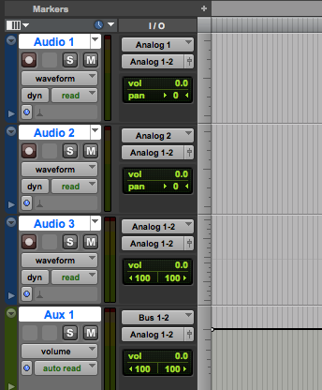

- Change the input/output routing if using alternate inputs.
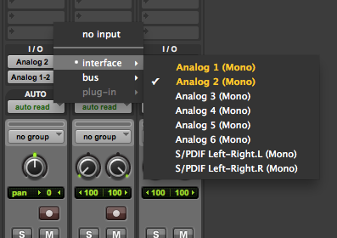 | 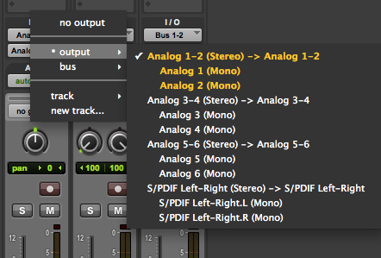

Logic X

- Ensure ‘Core Audio Manager’ is not running and therefore allowed to start up before/together with the DAW.
- Launch Logic from the Mac OSX Dock.
- If you have issues launching any DAW software, please restart the Mac.
- At the on-screen dialogue, select a new project or open a previous session.
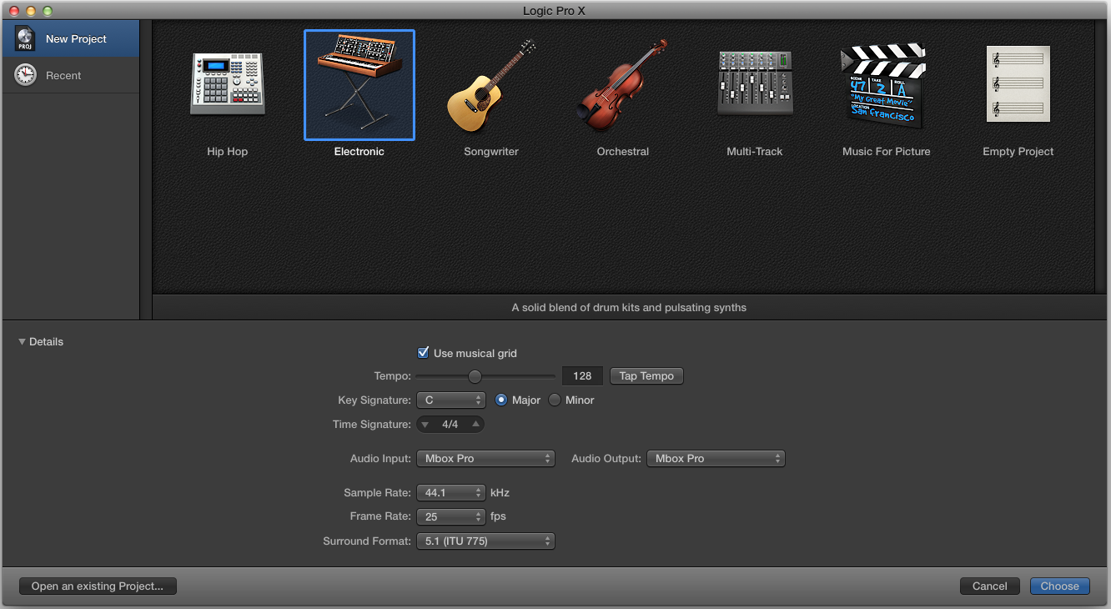
- If launching a new project ensure the following parameters are chosen:
- Audio Input and output: Focusrite Scarlett 18i20 (to ensure the I/O routing is correct).
- 44.1KHz Sample Rate (or higher if desired).
- Surround Format: 5.1 (ITU 775) (to ensure correct stereo routing).
- Click Choose to proceed. A project with several pre-programmed tracks will open.
- Save your session with an appropriate name using the Data or Data2 drive only!
- Saving to a different location will result in your work being automatically deleted upon system restart.
- If not already existing, create your own folder on the chosen drive using your p-number and name.
- All subsequent projects can be saved inside there with a corresponding title.
- Ensure your track routing is correct (Input and output routing).
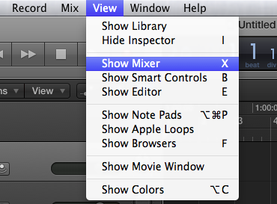

- Ensure input 1 is selected if your microphone is patched into wall input 1.
- Ensure ‘Stereo Output’ (or in case you want to stay mono: Mono -> ‘Output 1’) is chosen.
- The output menu opens using the right mouse button (or ctrl-click).
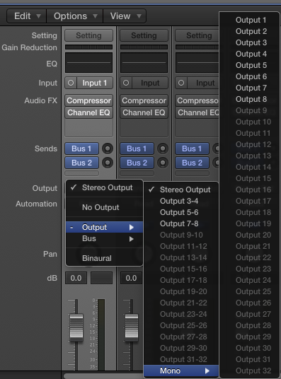
- Return to the arrange window, arm the respective track, check the input levels and start recording.

Reaper

- Ensure ‘Core Audio Manager’ is not running and therefore allowed to start up before/together with the DAW.
- Launch Reaper from the Mac OSX Dock.
- If you have issues launching any DAW software, please restart the Mac.
- Check the right audio interface is chosen in the ‘Preferences‘ menu.
- Audio Input and output: Focusrite Scarlett 18i20 (to ensure the I/O routing is correct).
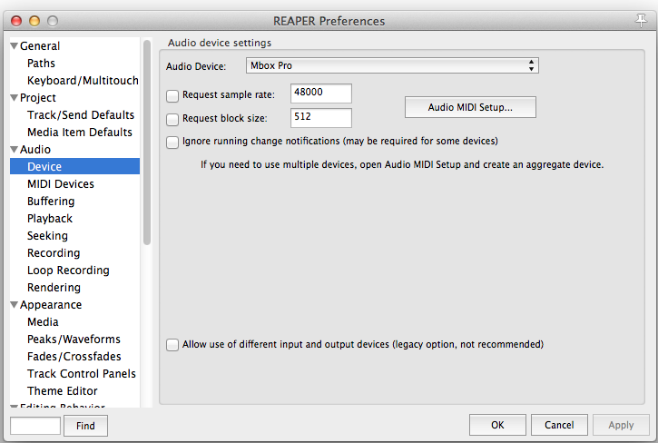
- If launching a new project ensure the for your project appropriate sample frequency in the ‘Project settings…’ is chosen:
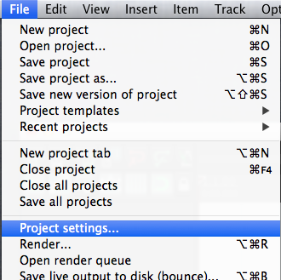 |  | 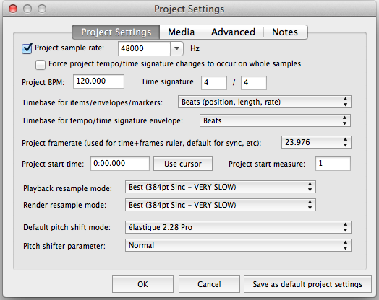
- Save your session with an appropriate name using the Data or Data2 drive only!
- Saving to a different location will result in your work being automatically deleted upon system restart.
- If not already existing, create your own folder on the chosen drive using your p-number and name.
- All subsequent projects can be saved inside there with a corresponding title.
- Create a new track.
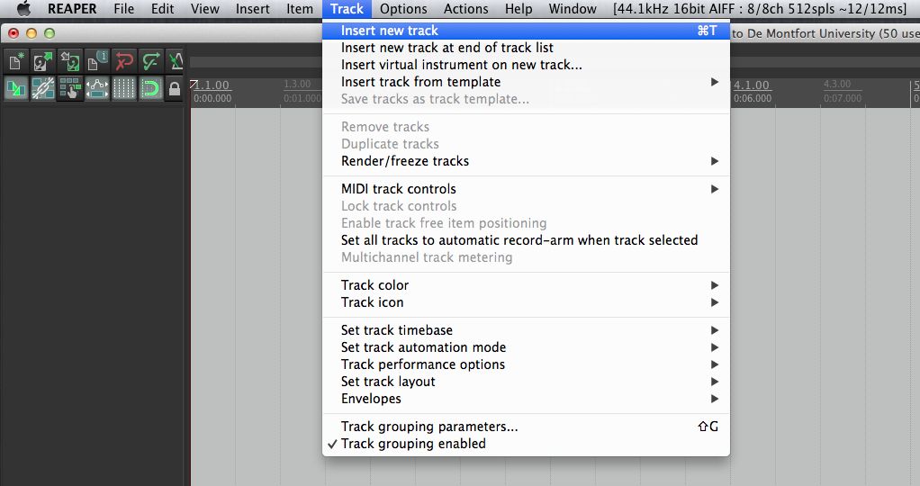

- Ensure your track routing on the track is correct (Input and output routing).
- Ensure input 1 is selected if your microphone is patched into wall input 1.
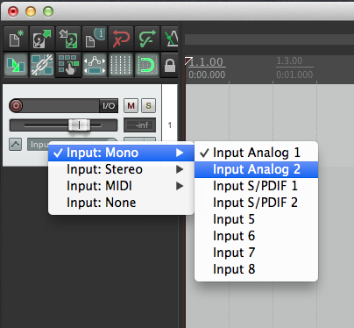
- If recording in stereo, ensure ‘Stereo Input’ is chosen.
(Input 5 & 6 are the inputs from the 3.5 (mini) jack cable).
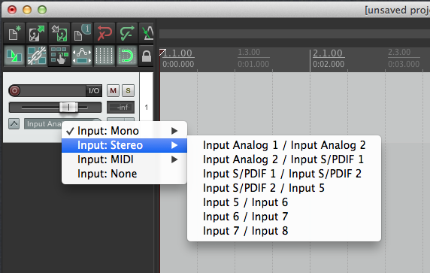
- Adjust the input gain through the software of the Mbox Pro:
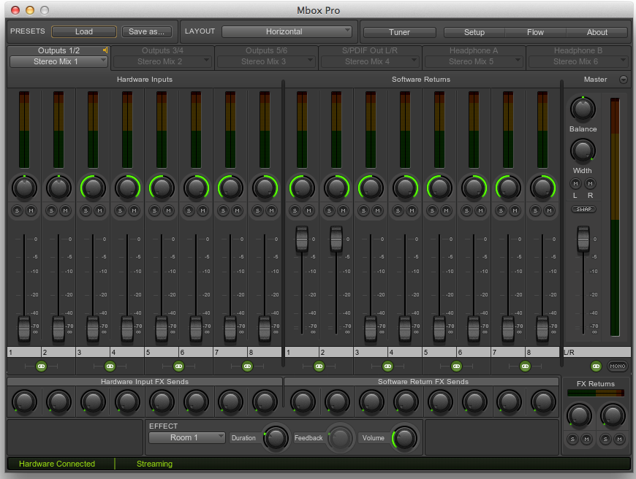
- Return to Reaper, arm the respective track, check the input levels and start recording.
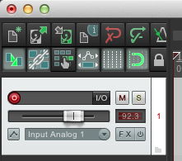

External MacBook/Laptop Setup

External devices can be connected with help of a 3.5 (mini jack) cable, which is connected to inputs 7/8 on the Focusrite Scarlett 18i20 audio interface.
- Start the software program for the Focusrite Scarlett which is to be found in the Dock.
- A stereo ¼ inch jack to 3.5m (aux) should be connected, before plugging this into your MacBook/Laptop, ensure the volume is down/muted…
- Ensure the speakers are switched on.
- Open the faders for channels 7/8 on the software.
- Play back sound on your device.
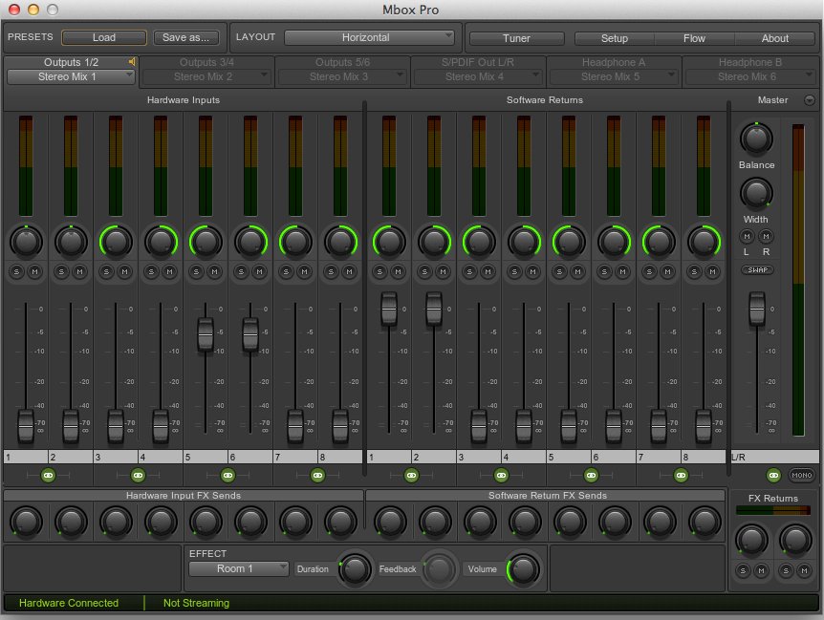

Moving Pro Tools 2019 Projects

NOTE:
It is important that all audio files, which are used within the project, have been imported into the Pro Tools session. This happens in one of two ways:
- Dragging and dropping (Pro Tools automatically copies and converts files).
- ‘File -> Import -> Audio…’
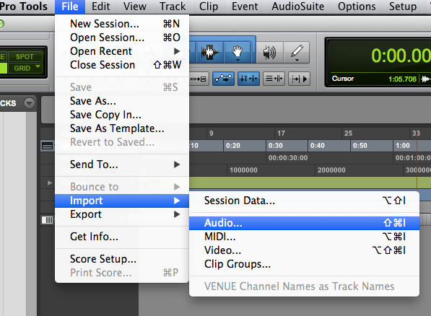
Upon import always choose either ‘Copy’ / ‘Copy All’ (for audio files at the same sample frequency and bit rate) or ‘Convert’ / ‘Convert All’ (for audio files differing from the session’s sample frequency or bit rate). This will copy the audio file(s) into the standard folder for audio files labelled ‘Audio Files’ within the Pro Tools session. The parameters of the audio file to be imported can be seen on the middle left in the import window.
Choosing ‘Add’ or ‘Add All’ will not copy the files, but only create links to the original position, leaving the respective file(s) unavailable without the original source. It is then, that Pro Tools asks to relink audio files from other sources, when the session is opened on a different computer.

Session with same sample/bit rate | 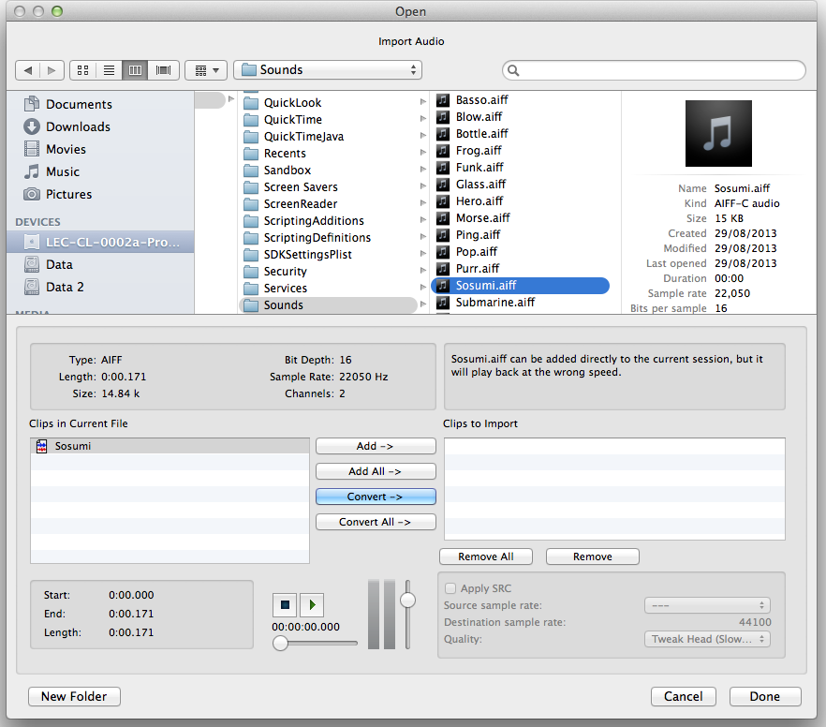  Session with different same sample/bit rate

Sharing Pro Tools sessions
If a session is being shared between various computers with different audio interfaces, Pro Tools will prompt and ask for instructions. It is important to be aware of following distinctions:
Pro Tools 2019 | => | Pro Tools 2019HDX
Up to 128 tracks |  | Up to 768 tracks
128 Aux input tracks |  | 512 aux input tracks
128 instrument tracks |  | 256 instrument tracks

The Foley Studio (CL00.16a) is equipped with Pro Tools 2019 and a Focusrite 18i20 audio interface.
Be aware that there are more plugins available in the main studios as opposed to the smaller ones or the sound booths!

Transferring a Pro Tools 2019 session to Pro Tools 2019 HDX:
When opening a Pro Tools 2019 HDX session in Pro Tools 2019 the program will recognise that the session has not been created with the same audio interface:
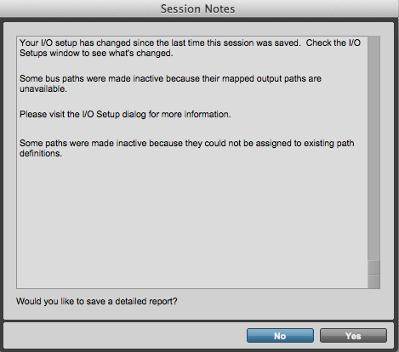 |  | 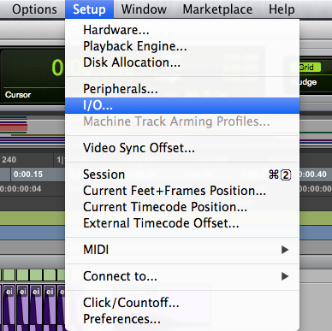
Confirm the ‘Session Notes’ and adjust the old input/output routing to match the new studio and audio interface simply by modifying the settings in Pro Tool’s ‘I/O Setup’. Then save your session under a new name and continue working.

Opening Pro Tools 2019 HDX session in Pro Tools 2019:
When opening a Pro Tools 2019 HDX session in Pro Tools 2019 the program will recognise that the session has not been created with the same audio interface:
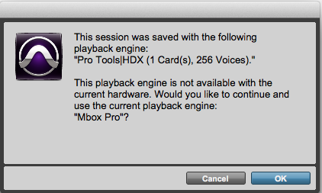
Confirm the message box and adjust your I/O Setup. Then save your session under a different name to prevent a mix up and continue working.

Since the studios do have more choices regarding plug-ins, be aware that it might not be available in a smaller studio or the sound booths. In case you have chosen a plugin which is not available on the computer, Pro Tools will open a session note message box, informing about the missing plug-ins.
These are then greyed out (=unavailable) in the session.
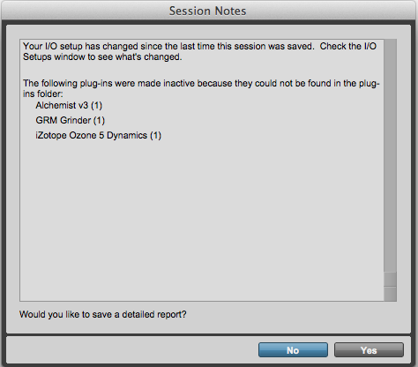 |  | 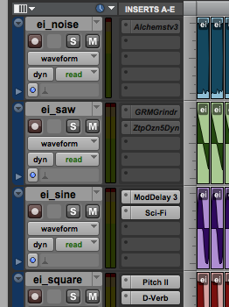

Sharing between different OS
If you want to know more about how to move Pro Tools 2019 sessions between different operating systems (e.g. Windows and Mac), please refer to the user manual (‘Pro Tools Reference Guide’, v11.1, p. 369ff).

Sharing between older versions of Pro Tools
If you want to know more about how to move Pro Tools 2019 sessions to older versions of Pro Tools, please refer to the user manual (‘Pro Tools Reference Guide’, v11.1, p. 372ff).

