# GETTING STARTED WITH SFTP

You can use SFTP to access the files in your DMU h: drive from a remote (offsite) computer. When you are logged in to SFTP you can download files from your h: drive to your computer and upload files from your computer to your h: drive.

1. In order to use SSH or SFTP you need to download and install an SFTP client on your computer.
2. There are several free SFTP clients that you can download. Windows users should find **WinSCP**

straightforward to download and install and also straightforward to use.

1. See [**http://www.tech.dmu.ac.uk/SFTP/SFTP.html**](http://www.tech.dmu.ac.uk/SFTP/SFTP.html%20) for details of some other free SFTP clients, including clients for non-Windows operating systems.

# DOWNLOADING AND INSTALLING WinSCP

1. WinSCP can be downloaded from [**https://winscp.net/eng/download.php**](https://winscp.net/eng/download.php)
2. Click on the ‘Download WinSCP’ button. Be careful not to click on the advertising downloads which are higher up the page than the WinSCP download.



1. This will download a file called WinSCP-5.17.2-Setup.exe. (It may have a different number if an updated version of WinSCP has been released.)



1. Double click on the downloaded file.
2. You can choose to ‘Install for all users’ or ‘Install for me only’.

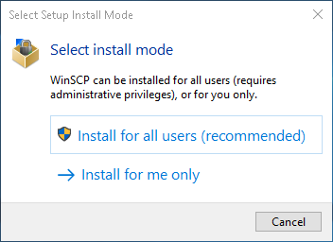

1. Click ‘Accept’ to accept the License Agreement and on the screens which follow, once you see the ‘Install’ button please select it.



1. 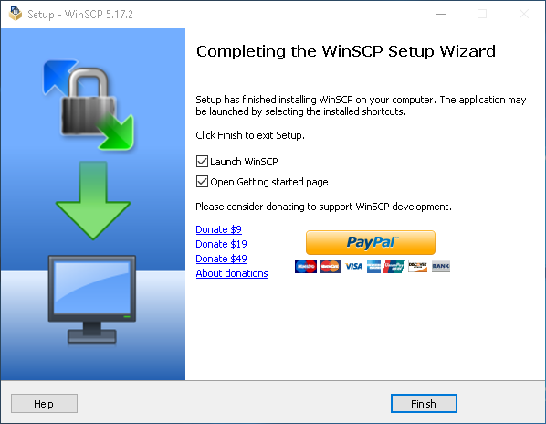Click ‘Finish’ and Launch WinSCP if it did not automatically Launch. This can be done by double clicking the new icon on your desktop, or by searching for WinSCP in your start menu.

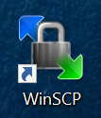

**LOGGING IN TO WinSCP**

1. When WinSCP has launched please enter the following information

* Leave the ‘File protocol’unchanged ‘SFTP’ [1]
* Enter ‘sftp.dmu.ac.uk’in the ‘Host name’ box [2]
* Leave the ‘Port number’unchanged ‘22’ [3]
* Enter your p-number in the ‘User name’box [4]
* Enter your password in the ‘Password’box [5]
* Click ‘Login’ [6]

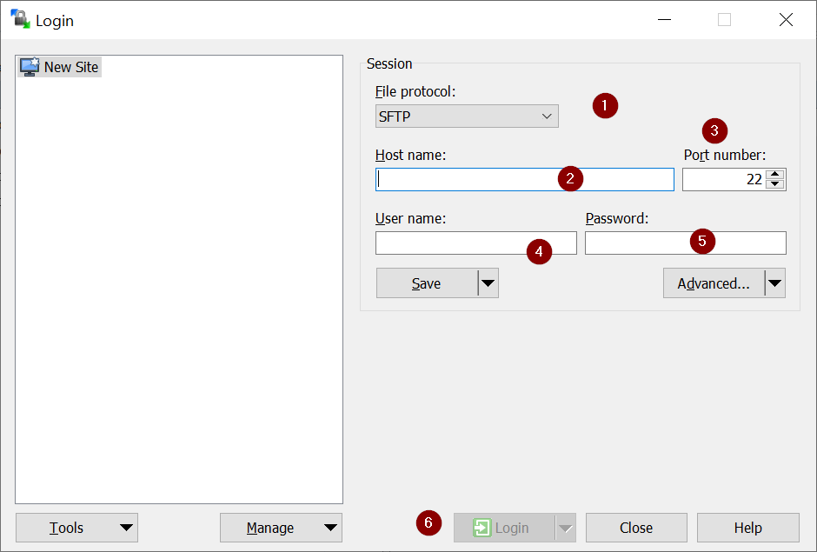

1. 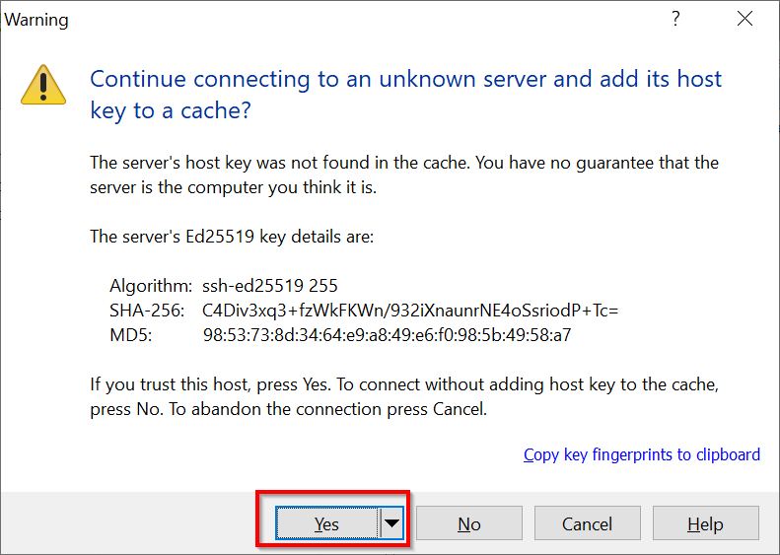If you see the following pop up window, select ‘Yes’.

This should only happen the first time you log in.

1. When you have logged in a window will open with two panes. The left-hand pane is your directory on the computer which you launched WinSCP from. The right-hand pane is your DMU h: Drive. You can manage the files in each pane using the menu buttons and drag and drop files between the two panes.

